1. **CREATE TABLE**

drop table if exists goldusers_signup;

CREATE TABLE goldusers_signup(userid integer,gold_signup_date date);

drop table if exists users;

CREATE TABLE users(userid integer,signup_date date);

drop table if exists sales;

CREATE TABLE sales(userid integer,created_date date,product_id integer);

drop table if exists product;

CREATE TABLE product(product_id integer,product_name text,price integer);

1. **INSERT DATA**

INSERT INTO goldusers_signup(userid,gold_signup_date)

VALUES (1,'09-22-2017'),

(3,'04-21-2017');

INSERT INTO users(userid,signup_date)

VALUES (1,'09-02-2014'),

(2,'01-15-2015'),

(3,'04-11-2014');

INSERT INTO product(product_id,product_name,price)

VALUES

(1,'p1',980),

(2,'p2',870),

(3,'p3',330);

INSERT INTO sales(userid,created_date,product_id)

VALUES (1,'04-19-2017',2),

(3,'12-18-2019',1),

(2,'07-20-2020',3),

(1,'10-23-2019',2),

(1,'03-19-2018',3),

(3,'12-20-2016',2),

(1,'11-09-2016',1),

(1,'05-20-2016',3),

(2,'09-24-2017',1),

(1,'03-11-2017',2),

(1,'03-11-2016',1),

(3,'11-10-2016',1),

(3,'12-07-2017',2),

(3,'12-15-2016',2),

(2,'11-08-2017',2),

(2,'09-10-2018',3);

1. **SELECT TABLE**

select * from sales;

select * from product;

select * from goldusers_signup;

select * from users;

1. **QUERY**
2. What is the total amount each customer spent on Zomato ?

select a.userid, sum(b.price) Amount_Spent from sales a inner join product b

on a.product_id = b.product_id group by a.userid;

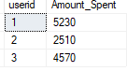

1. How many days has each customer visited Zomato ?

select userid, count(distinct(created_date)) distinct_days from sales group by userid;

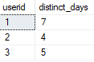

1. What was the first product purchased by each customer ?

select * from

(select *, RANK() over(partition by userid order by created_date) rnk from sales) a where rnk = 1;

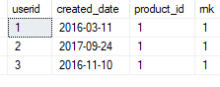

1. What is the most purchased item on the menu and how many times was it purchased by all customer?

Select userid, count(product_id) cnt from sales where product_id =

(select TOP 1 product_id from sales group by product_id order by count(product_id) DESC) group by userid;

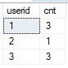

1. Which item was the most popular for each customer?

select * from

(select *, rank() over(partition by userid order by cnt desc) rnk

from

(select userid, product_id, count(product_id) cnt from sales group by userid, product_id) A) B where rnk = 1;

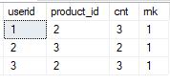

1. Which item was purchased first by the customer after they become a member ?

Select * from

(Select c.*, rank() over(partition by userid order by created_date) rnk from

(select a.userid, a.created_date, a. product_id, b.gold_signup_date from sales a inner join goldusers_signup b on a.userid = b.userid and a.created_date >= b.gold_signup_date) c)d where rnk = 1;

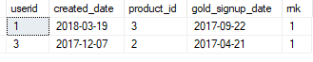

1. Which item was purchased first before the customer become a member ?

Select * from

(Select c.*, rank() over(partition by userid order by created_date desc) rnk from

(select a.userid, a.created_date, a. product_id, b.gold_signup_date from sales a inner join goldusers_signup b on a.userid = b.userid and a.created_date <= b.gold_signup_date) c)d where rnk = 1;

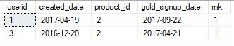

1. What is the total orders and amount spent for each member before they become member?

select userid, count(created_date) order_purchased, sum(price) total_amt_spent from

(Select c.*, d.price from

(select a.userid, a.created_date, a. product_id, b.gold_signup_date from sales a inner join goldusers_signup b on a.userid = b.userid and a.created_date <= b.gold_signup_date) c inner join product d on c.product_id = d.product_id) e group by userid

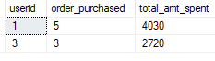

1. If buying each product generates points for eg 5rs = 2 zomato point and each product has different purchasing points for eg for p1 5rs = 1 zomato point, for p2 10rs = 5 zomato points and p3 5rs = 1 zomato point. 2rs = 1 zomato point.

Select userid, sum(Total_Points)*2.5 as Total_Points_Earn from

(select e.*, amt/Points Total_Points from

(select d.*, case when product_id =1 then 5 when product_id =2 then 2 when product_id =3 then 5 else 0 end as Points from

(select c.userid, c.product_id, sum(price) as amt from

(select a.*, b.price from sales a inner join product b on a.product_id = b.product_id) c group by c.userid, c.product_id) d) e) d group by userid;

1. In the first one year after a customer joins the gold program (including their join date) irrespective of what the customer has purchased they earn 5 zomato points for every 10 rs spent who earned more 1 or 3 and what was their points earnings in their first year ?

1 zomato point = 2 rs

select c.*, d.price*0.5 total_point_earned from

(select a.userid, a.created_date, a. product_id, b.gold_signup_date from sales a inner join goldusers_signup b on a.userid = b.userid and a.created_date >= b.gold_signup_date and created_date<= DATEADD(year, 1, gold_signup_date)) c

inner join product d on c.product_id = D.product_id;

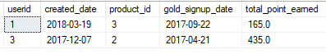

1. Rank all the transaction of the customer

select *, DENSE_RANK() over(partition by userid order by created_date) rnk from sales;

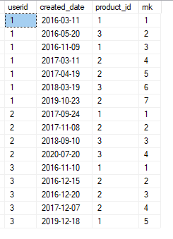

1. Rank all the transaction for each member whenever they are a Zomato gold member for every non gold member transaction mark as NA

select e.userid,created_date, product_id,gold_signup_date, case when rnk =0 then 'na' else rnk end as New_Rank from

(select c.*, cast((case when gold_signup_date is null then 0 else Dense_rank() over(partition by userid order by created_date desc) end) as varchar) as rnk from

(select a.userid, a.created_date, a. product_id, b.gold_signup_date from sales a left join goldusers_signup b on a.userid = b.userid and a.created_date >= b.gold_signup_date) c) e

